ELK’s reasoning attitude against Snomed CT v. Jan’17

1. I have made an experiment on my mobile device using Snomed CT v. Jan’17, not v. Jan’11.

The result is an exception as shown below:

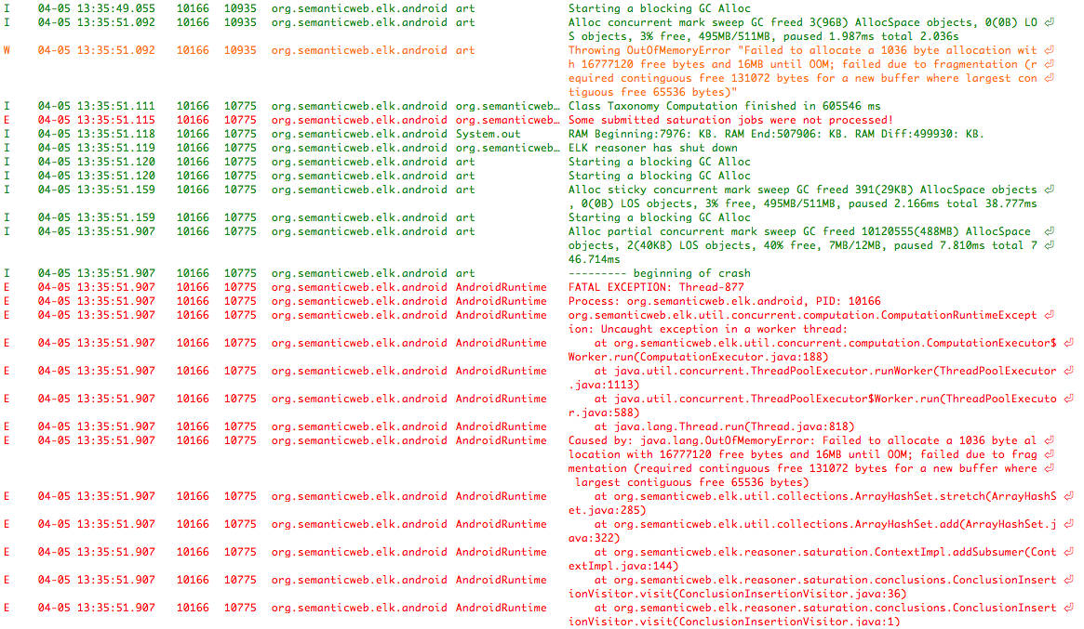

|  |  |  |
| --- | --- | --- |
| C:\Users\r01ig15\Dropbox\Isa's project\Related Work\01 Reviews\20170405 SnomedCT Jan17\Screenshot_20170405-132420.png | C:\Users\r01ig15\Dropbox\Isa's project\Related Work\01 Reviews\20170405 SnomedCT Jan17\Screenshot_20170405-133600.png | C:\Users\r01ig15\Dropbox\Isa's project\Related Work\01 Reviews\20170405 SnomedCT Jan17\Screenshot_20170405-130850.png |

1. I have started extracting different amounts of knowledge from SnomedCT v.Jan’17.